Intro to polynomials worksheet Name :_________________________________

Determine if the following are polynomials. If so, state the degree and leading coefficient. If not, circle the problem.

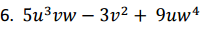
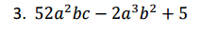
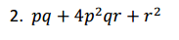
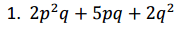

7. $5x^{-2}+1$ 8. ${3x}^{4}-7x$ 9. $3x^{1/2}-8$

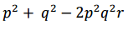
10. 11. $x^{2}y+8xy^{3}+xyz$ 12. $\frac{6x^{2}+3x}{3x}$

13. $\frac{2xy^{2}}{5x}$ 14. $7x^{5}y+7y$ 15. $\frac{3x^{2}-5y}{10x}$

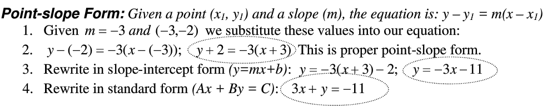

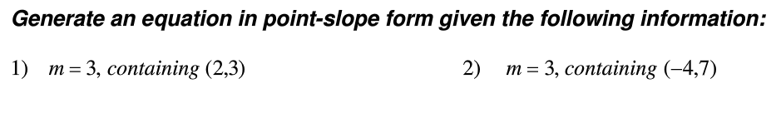

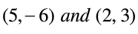
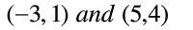
5) 6)

